UNIVERSITY OF RWANDA

College of Science and Technology
School of ICT

Department of Computer and Computer and Software Engineering

Data Structures and Algorithms

PROJECT REPORT

City Bus Station Scheduling and Boarding System

Lecturer: Ntalindwa Theoneste

Group Members:
NSENGIMANA GILBERT — 224014348
NSHUTI NGENDAHAYO HUBERT ---224006525
IRADUKUNDA ENOCK ------ 224004620

Date: 09 March 2026

TABLE OF CONTENT

City Bus Station Scheduling and Boarding System 2

Introduction 2
Objectives 2
Data Structures Used 2
Queue 2
Example: 3
Passenger Queue 3
Boarding order: 3
P1 boards first P2 boards second 3
System Design 4
System Flow 4
Algorithm 5
Implementation 5
Sample Output 9
Time Complexity Analysis 10
Conclusion 10
References 11

City Bus Station Scheduling and Boarding System

Introduction
Bus terminals handle a large number of buses and passengers daily. Efficient scheduling and passenger management are essential to maintain smooth operations and minimize delays.
Traditional manual systems may lead to inefficiencies such as long waiting times and poor scheduling. By implementing appropriate data structures such as queues and priority queues, bus stations can automate scheduling and passenger boarding.
This project develops a simulation of a city bus station scheduling and boarding system using C++. The system allows users to add buses, manage passenger queues, simulate boarding, delay buses, and cancel buses.

Objectives
The main objectives of this project are:
- To use a queue for managing passenger boarding.
- To implement a priority queue for scheduling buses.
- To simulate real-world bus terminal operations.
- To demonstrate the application of data structures in transportation systems.
- To develop a menu-driven console application using C++.

Data Structures Used

Queue
A queue is a FIFO (First In First Out) data structure.
It is used to manage passengers waiting to board buses.
Operations used:
- Enqueue (add passenger)
- Dequeue (remove passenger)

Example:

Passenger Queue
P1 → P2 → P3 → P4

Boarding order:

P1 boards first
P2 boards second

Priority Queue
A priority queue stores elements based on priority value instead of insertion order.
In this project it is used to schedule buses based on:

- Departure time
- Urgency

Example:
BUS | PRIORITY
Bus A | 1
Bus B | 2
Bus C | 0
Bus C departs first because it has the highest priority.

System Design
The system contains two main components:

Bus Management
- Add buses
- Schedule buses
- Delay buses
- Cancel buses

Passenger Management
- Add passengers
- Manage passenger queue
- Board passengers

System Flow
Program flow:
Start Program
Display Menu
User selects operation:
Add Bus
Add Passenger
View Schedule
Start Boarding
Delay Bus
Cancel Bus
Passengers board bus until capacity reached
Bus departs
Repeat until exit

Algorithm (flow chart)
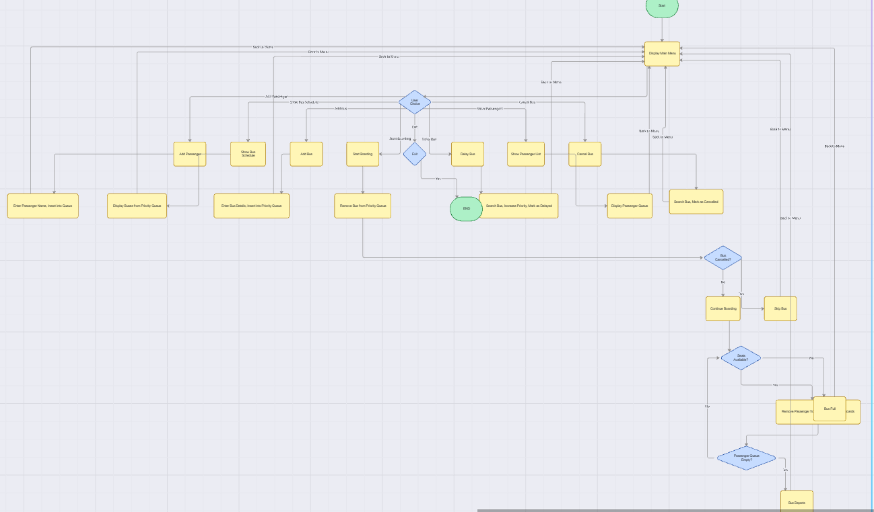

Bus Scheduling Algorithm
1 Insert bus into priority queue
2 Compare bus priority
3 Bus with highest priority is selected
4 Bus proceeds to boarding

Passenger Boarding Algorithm
1 Bus arrives
2 Check bus capacity
3 Remove passengers from queue
4 Assign passenger to bus seat
5 Continue until bus is full or queue is empty
6 Bus departs

Implementation
The system is implemented using C++ programming language.

#include <iostream>
#include <queue>
#include <vector>
#include <string>
using namespace std;

class Bus {
public:
int busID;
string route;
int departureTime;
int priority;
int capacity;
bool cancelled;
bool delayed;

Bus(int id, string r, int d, int p, int c) {
busID = id;
route = r;
departureTime = d;
priority = p;
capacity = c;
cancelled = false;
delayed = false;
}
};

class CompareBus {
public:
bool operator()(Bus a, Bus b) {
return a.priority > b.priority;
}
};

priority_queue<Bus, vector<Bus>, CompareBus> busQueue;
queue<string> passengerQueue;

void addBus() {
int id, dep, pri, cap;
string route;
cout << "\nEnter Bus ID: ";
cin >> id;

cout << "Enter Route: ";
cin >> route;

cout << "Enter Departure Time: ";
cin >> dep;

cout << "Enter Priority (lower number = higher priority): ";
cin >> pri;

cout << "Enter Capacity: ";
cin >> cap;

busQueue.push(Bus(id, route, dep, pri, cap));

cout << "Bus added successfully.\n";
}

void addPassenger() {
string name;
cout << "Enter Passenger Name: ";
cin >> name;
passengerQueue.push(name);

cout << "Passenger added to waiting queue.\n";
}

void showPassengers() {

if (passengerQueue.empty()) {
cout << "No passengers waiting.\n";
return;
}

queue<string> temp = passengerQueue;

cout << "\nPassenger Queue:\n";

while (!temp.empty()) {
cout << temp.front() << endl;
temp.pop();
}
}

void showBusSchedule() {

if (busQueue.empty()) {
cout << "No buses scheduled.\n";
return;
}

priority_queue<Bus, vector<Bus>, CompareBus> temp = busQueue;

cout << "\nBus Schedule\n";

while (!temp.empty()) {

Bus b = temp.top();
temp.pop();

cout << "Bus ID: " << b.busID
<< " | Route: " << b.route
<< " | Departure: " << b.departureTime
<< " | Capacity: " << b.capacity;

if (b.cancelled)
cout << " | Cancelled";

if (b.delayed)
cout << " | Delayed";

cout << endl;
}
}

void cancelBus() {

if (busQueue.empty()) {
cout << "No buses available.\n";
return;
}

int id;
cout << "Enter Bus ID to cancel: ";
cin >> id;

priority_queue<Bus, vector<Bus>, CompareBus> temp;

while (!busQueue.empty()) {

Bus b = busQueue.top();
busQueue.pop();

if (b.busID == id) {
b.cancelled = true;
cout << "Bus " << id << " cancelled.\n";
}

temp.push(b);
}

busQueue = temp;
}

void delayBus() {

if (busQueue.empty()) {
cout << "No buses available.\n";
return;
}

int id;
cout << "Enter Bus ID to delay: ";
cin >> id;

priority_queue<Bus, vector<Bus>, CompareBus> temp;

while (!busQueue.empty()) {

Bus b = busQueue.top();
busQueue.pop();

if (b.busID == id) {
b.delayed = true;
b.priority += 2;
cout << "Bus " << id << " delayed.\n";
}

temp.push(b);
}

busQueue = temp;
}

void startBoarding() {

if (busQueue.empty()) {
cout << "No buses available.\n";
return;
}

Bus bus = busQueue.top();
busQueue.pop();

if (bus.cancelled) {
cout << "Bus " << bus.busID << " is cancelled.\n";
return;
}

cout << "\nBoarding Bus " << bus.busID << " (Route: " << bus.route << ")\n";

int seats = bus.capacity;

while (seats > 0 && !passengerQueue.empty()) {

cout << passengerQueue.front() << " boarded.\n";
passengerQueue.pop();
seats--;
}

if (seats == 0)
cout << "Bus is full.\n";

if (passengerQueue.empty())
cout << "No more passengers waiting.\n";

cout << "Bus " << bus.busID << " departed.\n";
}
void showMenu() {

cout << "\n========== CITY BUS TERMINAL SYSTEM ==========\n";
cout << "1. Add Bus\n";
cout << "2. Add Passenger\n";
cout << "3. Show Bus Schedule\n";
cout << "4. Show Passenger Queue\n";
cout << "5. Start Boarding\n";
cout << "6. Delay Bus\n";
cout << "7. Cancel Bus\n";
cout << "8. Exit\n";
}

int main() {

int choice;

while (true) {

showMenu();

cout << "\nEnter choice: ";
cin >> choice;

switch (choice) {

case 1:
addBus();
break;

case 2:
addPassenger();
break;

case 3:
showBusSchedule();
break;

case 4:
showPassengers();
break;

case 5:
startBoarding();
break;

case 6:
delayBus();
break;

case 7:
cancelBus();
break;

case 8:
cout << "Exiting system...\n";
return 0;

default:
cout << "Invalid option.\n";
}
}
}

Sample Output
Example program execution:
CITY BUS TERMINAL SYSTEM
1 Add Bus
2 Add Passenger
3 Show Bus Schedule
4 Show Passenger Queue
5 Start Boarding
Enter choice: 1
Bus added successfully
Enter choice: 2
Passenger John added
Enter choice: 5
Boarding Bus 101
John boarded
Bus departed

Time Complexity Analysis
Operation | Time Complexity
Add Bus | O(log n)
Remove Bus | O(log n)
Add Passenger | O(1)
Board Passenger | O(1)

Conclusion
This project demonstrates the practical use of data structures in managing transportation systems. By using queues and priority queues, the system efficiently handles bus scheduling and passenger boarding.
The implementation shows how data structures can improve operational efficiency in real-world scenarios such as bus terminals.

References
- Data Structures and Algorithms in C++ – Mark Allen Weiss
- Introduction to Algorithms – Cormen
- Lecture notes – Data Structures module

